Rounding

Write the following numbers correct to

- the nearest whole number

- two decimal places

- three significant figures

 |  | Nearest Whole Number | 2 Decimal Places (2dp) | 3 Significant Places (3sf)
Q1 | 8.174
Q2 | 19.617
Q3 | 20.041
Q4 | 0.81452
Q5 | 311.14
Q6 | 0.275
Q7 | 0.00747
Q8 | 15.62
Q9 | 900.12
Q10 | 3.555
Q11 | 5.454
Q12 | 20.961
Q13 | 0.0851
Q14 | 0.5151
Q15 | 3.071

Q13. Write these lengths correct to the nearest centimetre, a) 18.6 cm (b) 124.3 cm (c) 0.86 cm

Q14. A regular hexagon has sides of 3.64 cm. Calculate the length of its perimeter correct to the nearest millimetre.

Q15. Write out these numbers correct to, a) 2 significant figures and (b) 2 decimal places,
(i) 1.647 (ii) 1.063 (iii) 0.0948 (iv) 0.3042

Q16. A table is 2.15 m long and 0.96 m wide. Calculate its area correct to, a) the nearest square metre, (b) 1 decimal place and (c) 3 significant figures.

Q17. Use a ruler to find the perimeter of this shape in centimetres and give your answer to, a) the nearest centimetre and (b) 2 significant figures.

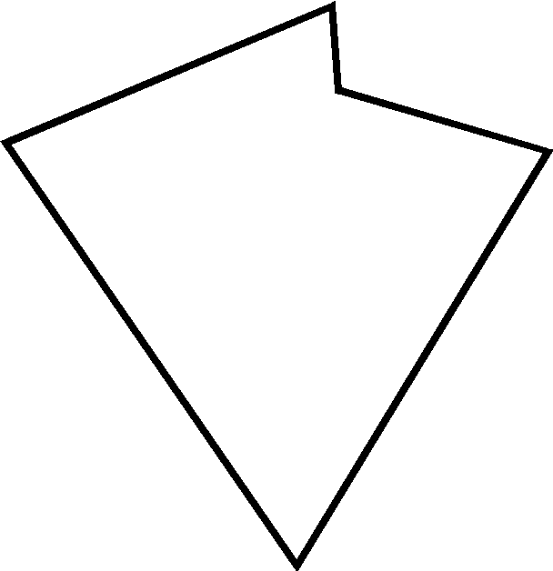

Q18. What are the least and greatest possible prices of an article which costs,
a) £8 to the nearest pound? (b) £12 to the nearest pound? (c) £190 to the nearest ten pounds? (d) £6.70 to the nearest 10p?

Q19. On three days of my holiday I travelled 67 miles, 84 miles and 42 miles. If these distances were measured correct to the nearest mile, find, a) the greatest possible value of the total distance travelled and (b) the least possible value of the total distance travelled.

Extension Task

In the table below fill in what the exact number could be and then fill in the other two blank values based upon your answer

 | Exact Number | Nearest Whole Number | 2 Decimal Places (2dp) | 3 Significant Places (3sf)
Q1 |  | 12
Q2 |  |  | 14.23
Q3 |  | 235
Q4 |  |  |  | 34.846
Q5 |  |  | 128.93
Q6 |  | 7
Q7 |  |  | 0.67
Q8 |  | 2570
Q9 |  |  |  | 1.96
Q10 |  |  |  | 35800
Q11 |  | 84
Q12 |  |  | 37.03
Q13 |  | 1678
Q14 |  |  | 200.10
Q15 |  |  |  | 0.00345

